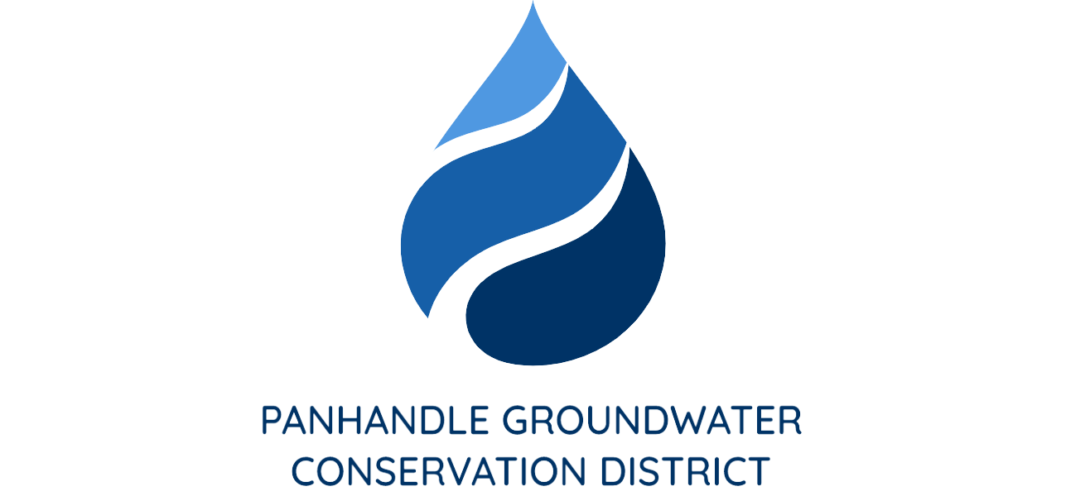

PRESS RELEASE
Contact: Britney Britten, General Manager
Panhandle Groundwater Conservation District
(806) 883-2501
britney@pgcd.us

FOR IMMEDIATE RELEASE

Texas Well Owner Network to Host Water Well Screening Event

WHITE DEER, TX. (October, 2022) – Texas Well Owner Network (TWON) is a free, educational training for Texas residents who depend on household wells for their water needs. TWON is for private well owners who want to become familiar with groundwater resources, septic system maintenance, well maintenance, water quality and water treatment.
TWON is hosting an educational meeting on Tuesday, November 15 from 4:00 p.m. to 5:00 p.m. in the Windmill Room at the Panhandle Groundwater Conservation District Office, 203 West Third in White Deer.
Well Owners may pick up sample containers with instructions at any of the following locations: Panhandle Groundwater Conservation District Office, 203 W Third St. in White Deer; Potter County Extension Office, 2201 SE 10th Ave, Building 1 in Amarillo; Armstrong County Extension Office, 100 Trice Street in Claude; Carson County Extension Office, 501 Main St. in Panhandle or Donley County Extension Office, 4430 Highway 70 North in Clarendon. Well owners may bring their water samples the day prior to the event (Monday, November 14) to be screened for nitrate-nitrogen, total dissolved solids (TDS), arsenic and E. coli bacteria, to any location mentioned above and between the times of 8:30 a.m. and 10:00 a.m. The cost per sample is $15.00.
“The District is thankful to participate in such an important event.” Said General Manager, Britney Britten. “We hope this is a great opportunity for our constituents to have their domestic water wells screened.”

Please call Aspen Edgar with any questions at 806-883-2501, or email, aedgar@pgcd.us

